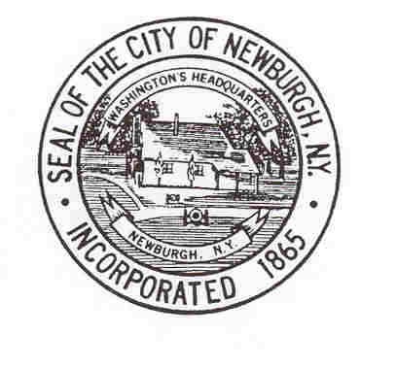City of Newburgh
City Comptroller’s Office
City Hall – 83 Broadway, 4th Floor Tel: (845) 569-7316
Newburgh, New York 12550 Fax: (845) 569-7490

Kathryn F. Nivins
Acting City Comptroller
knivins@cityofnewburgh-ny.gov

NOTICE
Request for Proposals (RFP #4.13)
for the

Operation of Carnival Rides, Concessions and Amusements for the

25th Annual International Festival

City of Newburgh, New York

Request for Proposals (RFP) will be received by the Acting City Comptroller in her office at City Hall, 83 Broadway, 4th floor, Newburgh, New York until 4:00 p.m., Eastern Time, Wednesday, June 5, 2013 for the Operation of Carnival Rides, Concessions and Amusements for the City of Newburgh’s 25th Annual International Festival.

Copies of the RFP may be obtained at the City Comptroller’s Office in City Hall, downloaded from the City’s website at http://www.cityofnewburgh-ny.gov/comptroller/pages/bids-and-rfps or by contacting Elizabeth Garrison, Administrative Assistant to the City Comptroller, via email at egarrison@cityofnewburgh-ny.gov. Vendors requesting the RFP by email must provide their complete contact information including physical street address, telephone and facsimile numbers as well as a contact person’s name.

Responders are required to execute a Non-Collusive Bidding Certification pursuant to Section 103d of the General Municipal Law of the State of New York. Responses submitted without a Non-Collusive Bidding Certification will not be considered.

Responses to this RFP shall be delivered to the Acting City Comptroller by hand, mail or other courier type services and must be received on or before the specified due date and time. Facsimile or electronic mail submissions will not be accepted. Vendors are responsible for timely delivery of their Proposals. There will be no exceptions.

The City of Newburgh hereby notifies all prospective vendors that it will affirmatively insure that in regard to any Contract entered into pursuant to this Notice, minority business enterprises will be afforded full opportunity to submit proposals in response to this invitation and will not be discriminated against on the grounds of race, color or national origin in consideration of an award.

The City of Newburgh reserves the right to reject any or all Proposals and to waive any informality or technicality in any Proposal in the interest of the City. Contract award shall be subject to approval by the City Council.

By Order of the City of Newburgh:

By:
Kathryn Nivins, Acting City Comptroller

Dated: Tuesday, May 21, 2013

“AN EQUAL OPPORTUNITY/AFFIRMATIVE ACTION EMPLOYER"

Advertisement Date: Hudson Valley Black Press: Wednesday, May 22, 2013
Mid-Hudson Times: Wednesday, May 22, 2013 Sentinel Tuesday, May 21, 2013

