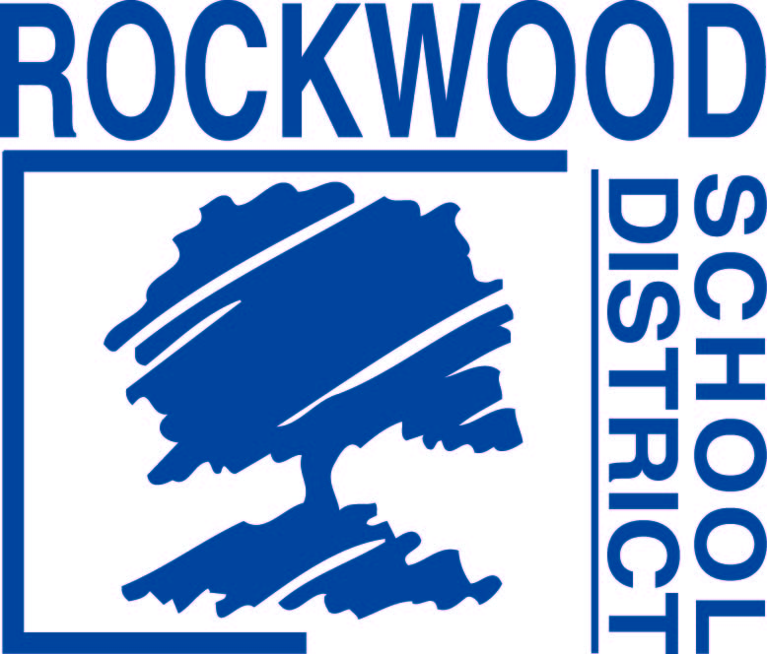
REQUEST FOR PROPOSAL #RFP0916COPYILC
Individualized Learning Center (ILC) Copier Bid
Addendum #1– September 15, 2016
Questions and Answers
1. Will you be asking the bidders to provide pricing that is fixed for the term, no annual increase. Yes, pricing must remain fixed throughout the term of the lease.
2. Will there be a public bid opening of the copier results on September 20, 2016? The bids will be read aloud at 3:00 PM at Rockwood School District’s Central Office, 111 E North St., Eureka, MO 63025.

