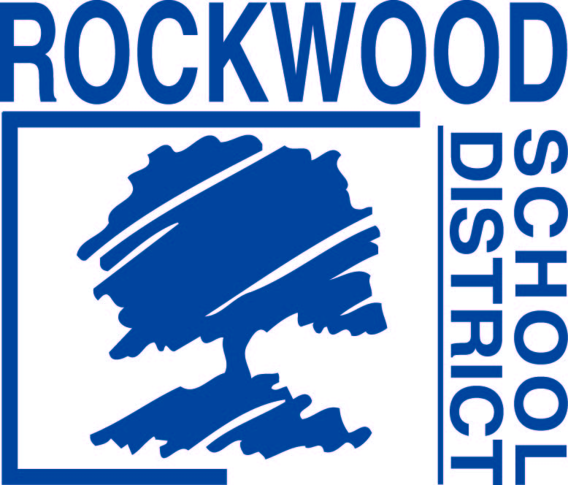

Addendum #1
Date: February 27, 2017
Rockwood School District -– RFQ0217MUSINST – 2017 Musical Instrument Bid
Questions and Answers
1. Line eight (8) is an Adams 4.3 Concert Marimba for Balog at Lafayette. That instrument is available with three different options for the bar material. It is available with bars of Rosewood, Padouk, or Adams synthetic material. There is a significant difference in price depending on which material is chosen. I would assume they would want the synthetic material, as that's the most popular, but I was wondering if you could verify which bar material he is wanting? The District would like synthetic bars for the marimba.
2. Line twenty-three (23) is a Blessing BTB-1280 Trombones for Smith at Selvidge. That is a discontinued model. The current student model Blessing trombone is the BTB-1287. Please replace the Blessing BTB-1280 trombone with the Blessing BTB-1287 Blessing trombone.
3. Line fifty-nine (59) is a Yamaha BB424X Bass Guitar for Winter at Marquette. That model has been discontinued. They aren't planning on announcing the replacement models until this summer. So, this is something that I can't bid on and unless a store has one in stock, this order will not be able to be fulfilled. Did the teacher have an alternative listed? We will accept a comparable substitution for the bass guitar.

