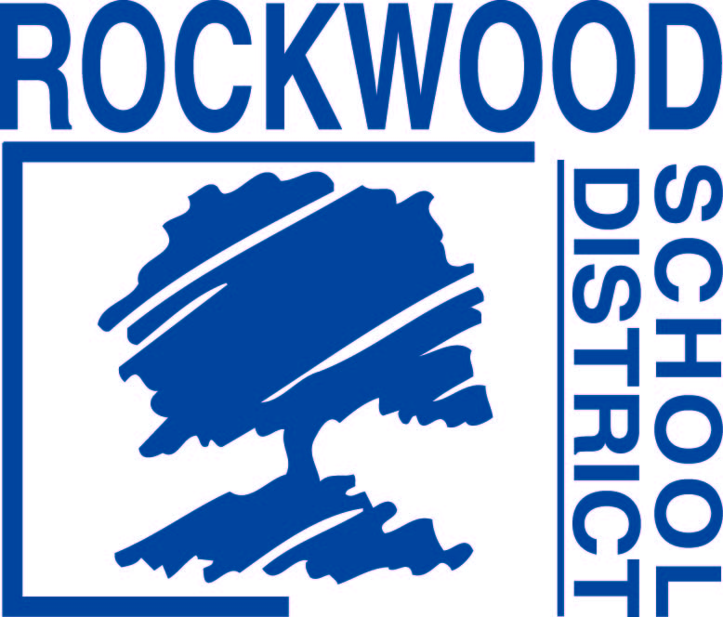

Addendum #1
Date: April 19, 2017
Rockwood School District - RFP0417HRFLSH – Annual Flu Shot Clinic
Questions and Answers
1. Will the District accept a proposal with the intention to only bill insurance? The ability to claim bill, list bill and allow for direct payment is preferred, however it is not mandatory.

