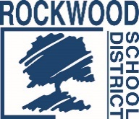
Addendum #2
Date: November 2, 2017
Rockwood School District – RFP1017HRBENA – Benefits Data Analytics System
Questions & Answers
- Who will the eligibility for insurance file be coming from? Either the District or the SmartBen, depending on the frequency needed and file set up.

