Administrative Center Brenda Kirchhoefer
111 East North Street Buyer
Eureka, MO 63025-1229

(636) 733-2045 Phone
(636) 733-8851 Fax
kirchhoeferbrenda@rsdmo.org
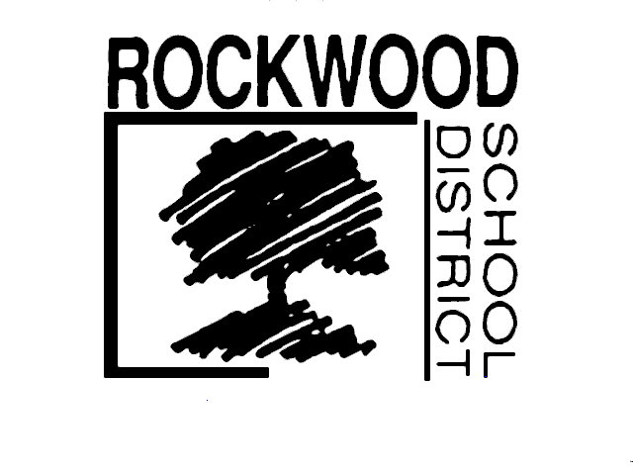

Growing Together,
Learning for Life

January 11, 2018

Dear Marching Band Uniform Specialists,

Re: Eureka High School Marching Band Uniforms Bid

The Rockwood School District invites sealed bids for the Eureka High School marching band uniforms to be used beginning with the 2018– 2019 school year. The purchases are targeted for April 2018. All bid prices must be firm for the year unless a lower price is offered due to additional manufacturer discounts or other price reductions. The District reserves the right to split the award or to make multiple awards, and to make award on a part or portion of a proposal.

Bids must be submitted on the attached forms. Note there are two tabs on the spreadsheet that must be completed (compliance and pricing sections) and sent to the attention of Brenda Kirchhoefer, Buyer, 111 East North Street, Eureka, MO, 63025-1229 no later than 3:00 P.M. on February 9, 2018. Please provide details for any non-complaint specs as this will not necessarily disqualify your bid. Bids received after the deadline or without the attached forms completed will be rejected. Please write Marching Band Uniforms – Eureka High School 2018/19 BID on the outside of the envelope.

Only bids complying with the following specifications will be considered.

- Two (2) hardcopies and one (1) electronic copy of bids must be received in the Purchasing Office by 3:00 P.M. on February 9, 2018. Bidders must submit offers using the attached spreadsheet.
- Bid prices must remain in effect from February 9, 2018 through August 1, 2018 unless lower prices are offered. Approximately 240 uniforms will be purchased.
- Bid prices must include shipping and handling.
- The District reserves the right to consider alternative bids if it is in the interest of the District. Bidders must complete the specification compliance section to confirm the level of compliance of each requirement and the Pricing section sheet included on the attached spreadsheet.
- Uniforms must be COMPLETELY WASHABLE AND DRYABLE in standard commercial and residential machines, eliminating the need for dry cleaning chemicals and resultant residue. Hence all items must meet exacting standards.
- Hair canvas, pre-shrunk wool, wool blend, felt, HYMO, or traditionally available materials used to lend shape to a garment will not be allowed. Nor will sub-standard glue-based inner linings be permitted. Shape of coats must be patterned into the garment, optimizing fabric grain and stability, not obtained through weighty layers of non-washable materials.
- All bidders must submit full, accurate samples/models/uniforms of client’s specific design or comparable fabric and design quality that can be test washed by customer, prior to awarding of bid. Uniforms will be due by February 23, 2018 and will be test washed prior to awarding bid.
- Uniform samples will be sent to:
Eureka High School
Attention: John Arata
4525 Highway 109
Eureka, MO 63025
- Please indicate shipping intervals from receipt of purchase order to ship date of each item in the comments area of the specification compliance document.

No verbal statements from any individual will be allowed to interfere or change the specifications as written. Corrections to bids received prior to the deadline must be written in red ink and noted next to the item and re-submitted prior to the original deadline of 3:00 PM on February 9, 2018. Changes will not be allowed after the deadline.

Thank you for your interest in working with the Rockwood School District. If you have any questions about the specifications, please contact me.

Sincerely,
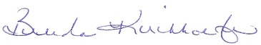
Brenda Kirchhoefer
Buyer

Enc. Picture of Uniform, Marching Uniform Specifications, and Pricing Spreadsheet

Picture of Proposed Eureka High Marching Band Uniform

