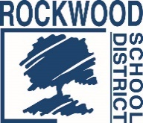
Addendum #1

Date: July 18, 2018

Bus Fleet Washing Services - RFP0718TRANSBW
The Request for Proposals (RFP) for the above named project is amended as noted in this Addendum.
Change in Specifications:
The selected vendor shall provide washing services to three (3) district locations.
- 17146 Manchester Rd., Wildwood, MO 63040
- 4555 Commerce Ave., High Ridge, MO 63049
- 25 Truitt Ave., Eureka, MO 63025
The requirement for proposers to provide Professional Error and Omission’s insurance has been removed.
Reponses to Proposers Questions:
Question 1: Is there currently a contract in place for fleet washing services? If so, please provide the pricing in the awarded bid.
Response: The District does not currently have a contract for bus fleet washing services.
Question 2: Are wash bays available for use?
Response: No

End of Addendum #1

