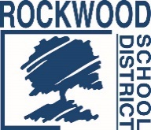

Date: March 5, 2019
Rockwood School District - RFITECH2019 - Request for Information – Student Chromebooks

- Question: Can the requested information be sent via email?
Response: Yes, an email submission is acceptable.

- Question: Will the district be buying Chromebook covers?
Response: No, the district does not have any current plans to purchase Chromebook covers.

