ROCKWOOD SCHOOL DISTRICT

REQUEST FOR PROPOSALS

RFP No.: RFPObsoleteTextbooks2019

Title: Sale of Obsolete Textbooks & Supplies 2019

Issue Date: June 7, 2019

Sealed Bid Due Date: June 20, 2019 @ 11:00 a.m., CST

GENERAL INTRODUCTION TO BIDDERS

The Rockwood School District (the District) will be accepting sealed bids for the sale of obsolete textbooks & science supplies grades K-12. The obsolete textbooks are located throughout the district located in St Louis County Missouri. The textbooks & supplies will be available for inspection from June 10, 2019 thru June 14, 2019. Bidders wishing to inspect the materials should contact each building secretary to schedule an appointment prior to their arrival. (Refer to Exhibit A: Building Contact & Location Information)

Please follow the mailing or delivery instructions below. All inquiries of the RFP shall be in writing and directed to Veronica Woll, Purchasing Agent at wollveronica@rsdmo.org.

Bidders will submit the enclosed Bid Form as their proposal. Sealed bids must be received no later than 11:00 a.m. CST on Thursday, June 20, 2019. Please make sure the envelope is clearly marked “RFPObsoleteTextbooks2019”.

BIDS SHALL BE SUMBITTED TO:

Purchasing Agent
Rockwood School District
RFPObsoleteTextbooks2019
111 East North Street
Eureka, Missouri 63025

Bids will be opened at that time and the successful bidder will be notified by close of business on June 20, 2019. The District reserves the right to reject any and all proposals, and to waive any irregularities or informalities in any proposals. Conditional proposals will not be accepted.

Terms of this sale are a Cashier’s Check or Money Order, payable to Rockwood School District, and must be received by 3:30 p.m. on Friday, June 21, 2019. All books & supplies must be removed by the winning bidder by 3:00 p.m. on Friday, June 28, 2019.

Sincerely,

Veronica Woll
Purchasing Agent
(636) 733-2033

IMPORTANT DATES

June 7, 2019: RFP Issue Date
June 10—14, 2019: Textbooks-Supplies Available for Inspection at School Buildings
June 17, 2019: Deadline for RFP clarification
June 20, 2019: Sealed Bids Dues @ 11:00 a.m. CST/(Winning Bidder Notified by Close of Business)
June 21, 2019: Payment Due to Rockwood School District by 3:30 p.m. CST
June 21—28, 2019: Textbooks-Supplies to be Picked-Up from each School Building by Winning Bidder

TERMS & CONDITIONS

INFORMATION
Rockwood School District offers for sale all items on an “as is, where is” basis. The District is a “casual seller” of obsolete property and does not inspect, test, certify, or provide an express or implied warranty on the items(s) sold. The Buyer accepts the items(s) “as is, where is” and is responsible for their own verification of the item’s condition. Rockwood School District has strived to provide an accurate count of all items; however, some quantities may vary. The District is not responsible for accidents or items left after June 28, 2019.

BID PRICE
The bid process quoted must be the actual price Rockwood School District will receive. No deductions will be allowed for transportation charges, permits, commissions, etc. The bid price shall be inclusive of all textbooks-supplies listed on the attached spreadsheet(s).

Bid price must be entered in the space provided on the Bid Form. All information requested on the Bid Form must be entered, and the Bid Form must be signed to validate your bid. Unsigned bids will be rejected.

AWARD
The District reserves the right to split the award or to make multiple awards, and to make award on a part or portion of a proposal.

PAYMENT & REMOVAL
Terms of this sale are a Cashier’s Check or Money Order, payable to Rockwood School District, and the successful bidder will make full payment by 3:30 p.m. on June 21, 2019. The Rockwood School District will not be responsible for property after 3:00 p.m. on June 28, 2019. The successful bidder will be required to provide all equipment and labor or compete removal of property. The successful bidder will be responsible for damage to District property caused by moving.

ROCKWOOD SCHOOL DISTRICT

BID FORM

RFP No.: RFPObsoleteTextbooks2019

Sealed Bid Due Date: June 20, 2019 @ 11:00 a.m., CST

Company Name:____________________________________________________
Address:__________________________________________________________
City/State/Zip: _____________________________________________________
Telephone:________________________________Fax:_____________________

Representative's Name: ______________________________________________
Title:_____________________________________________________________
Telephone:________________________________Fax:_____________________
E-mail Address:_____________________________________________________

BID PRICE for OBSOLETE TEXTBOOKS & SUPPLIES: $ ______ _______

By signing the bid form, you agree to adhere to the stated Terms & Conditions

Company Name:_______________________________________
Authorized Signature:___________________________________
Printed Name:_________________________________________
Date:_________________________________________________

Exhibit A: Building Contact & Location Information

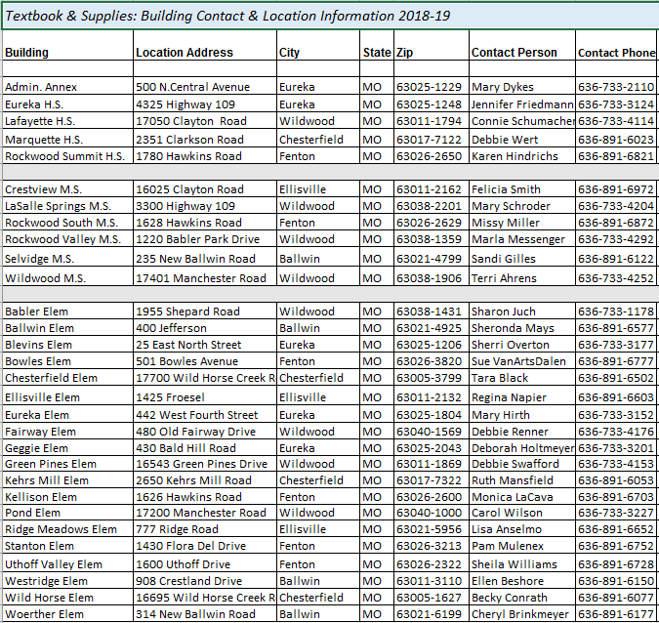

District Map

