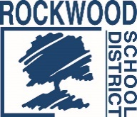

Addendum #2

Date: March 19, 2020
Rockwood School District – RFP No. RFPWHCON0120
WASTE HAULING SERVICES – ST. LOUIS AREA DISTRICT PARTNERSHIP
The Request for Proposals (RFP) for the above named project is amended as noted in this Addendum.
This Addendum consists of questions and Rockwood School District’s responses.
E-Scrap Recycling Service
1. Regarding the equipment for this service, is this equipment that has already gone through the govdeals.org auction process and are the units deemed too old or non-functioning and therefore will be picked up for recycling? Yes, the recycled items have already gone through the auction process. They may or may not be in working condition.
2. Do you require certified destruction of equipment with record of each individual serial number or will quantities only be acceptable? Quantities are preferred over itemized serial numbers.
End of Addendum #2

