BOARD OF COUNTY COMMISSIONERS
JACKSON COUNTY, FLORIDA

Project # 2021-13

Health Department Generator Repair

ADDENDUM 2
Questions and Answers

- Still need breaker type for H3 and H2 the Addendum 1 didn’t answer the full question:
Please clarify “adjustable breaker”.
(i.e. KH36150 or HDA36150U31X or HDA36150U33X or HDA36150U44X)
What degree of adjustability are we looking for?

Response: For feeder 'H', furnish/install non-adjustable Square D Breaker type 'HGA36125'. For feeder 'H1', furnish/install non-adjustable Square D Breaker type 'JGA36250'. ALD 02/22/21

Response: Panel ‘H2’ & ‘H3’: Square D Type ‘LX36400’
Photos below of the two existing breakers that are in the main switchgear that
currently serve these panels.
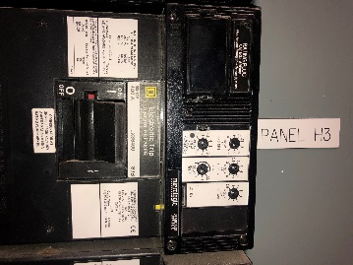
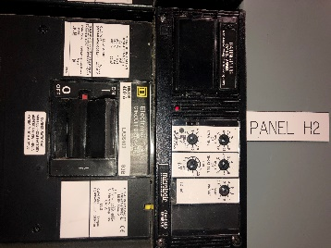

- In the bid documents this job requires a bid bond, but it also states that only jobs over $50,000.00 requires a bid bond. Does this job need a bid bond if it will be under $50,000.00?
Response: This bid does NOT require a bid bond and it will not exceed $50,000.
- Request to coordinate an on-site visit prior to bid deadline of 2/25/2021.
Response: All respondents who returned an ITP form have been invited to attend an on-site visit to review specifications and conditions of the existing generator and discuss requested modifications scheduled for 2/24/2021 @ 12PM CST.

