ADDENDUM 3
Additional Clarification

Will there be painting involved? Or will that be excluded?
Painting will be excluded from the bid.

The Base bid for shows to remove and replace sheetrock. I noticed most of this was already removed. Are there any areas that still need removed?
Sheetrock appears to have all been removed, contractors can exclude the remove portion from the Scope of Work.

Additional photos have been added to the website which should offer some clarification as to the locations of the individual rooms and Hallway locations per the Scope of Work.

https://jacksoncountyflgov-my.sharepoint.com/:b:/g/personal/pottsh_jacksoncountyfl_gov/EfCAs4EhxwdDq2fRIpWQbSkBUyxiK3xdmT6ymHj9jdWtHA?e=HzsYA1

The last item on the Base Bid Scope of work is referring to the damaged wall section along the back wall in the warehouse area.

Sheriff’s Office Metal Finishes Warehouse:
174.Remove and replace 480 SF of sheetrock ,120 FT long x 4 FT high.
175.Remove and replace 480 SF of batt wall insulation, 120 FT long x 4 FT high.

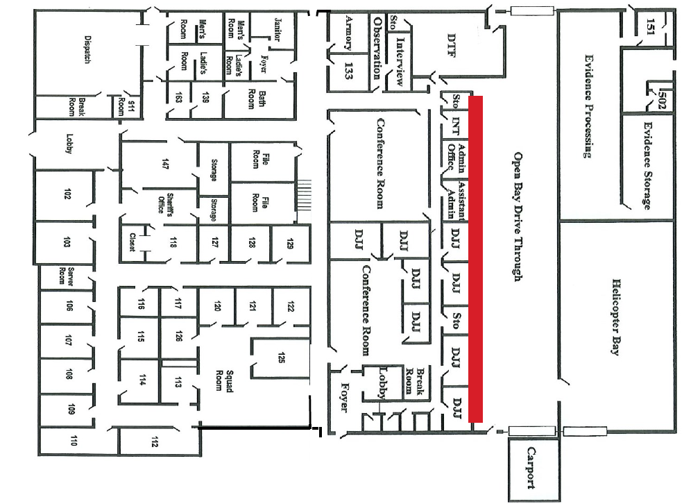

Bid due date and time remain unchanged. If additional time is needed to prepare bid submission, please contact the purchasing office at bradleyn@jacksoncountyfl.gov or call 850-482-9633.

