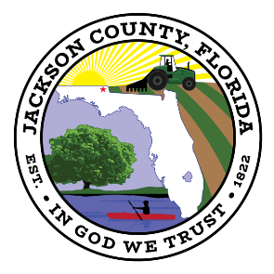
BOARD OF COUNTY COMMISSIONERS
JACKSON COUNTY, FLORIDA

Sale Bid # 2021-15

Sale of Surplus Travel Trailers

ADDENDUM 1
____________________________________________________________

The purpose of this addendum is to extend the deadline of October 6, 2021 to Friday, October 15, 2021 @ 2:00pm CST.

