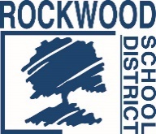
Addendum #1
Date: November 5, 2021
Rockwood School District – RFP No. RFP1101SURCOM
Telephone Survey Services

The Request for Proposals (RFP) for the above-named project is amended as noted in this Addendum. This Addendum consists of questions and Rockwood School District’s responses.

- How would you like the electronic copy submitted? Email is preferred if it is sent after the 2:00 pm deadline. The hard copies still need to be submitted prior to the deadline to be considered.

- Is the target audience registered voters ages 18 plus living in Rockwood? Yes

- Is the District open to a mixed methodology approach (digital and phone)? Yes, we will consider a mixed methodology.
- Do you have a contact list available (name and phone numbers) to reach your target audience or do you need the firm to procure these contacts? It would be the responsibility of the firm to procure the list.

End of Addendum #1

