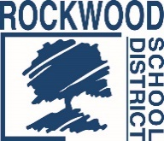
Addendum #2
Date: November 5, 2021
Rockwood School District – RFP No. RFP1101SURCOM
Telephone Survey Services

The Request for Proposals (RFP) for the above-named project is amended as noted in this Addendum. This Addendum consists of questions and Rockwood School District’s responses.

1. Has the District conducted work like this before? Yes, but it has been some time ago and we do not have the details.
a. If so……when were the last two times an endeavor similar to this was completed?
b. How many completed interviews were conducted each time?
c. How long (in either length of time or number of questions) was the survey instrument?
2. Is being a registered to vote a criterion of the audience to be measured? Yes
3. Does the target audience have to represent those who have school-aged children, or does it include all residents within the District (since they all have a right to vote on the ballot)? All registered voters.

End of Addendum #2

