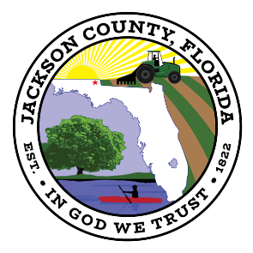
BOARD OF COUNTY COMMISSIONERS
JACKSON COUNTY, FLORIDA

RFQ # 2021-03

ADDENDUM 1 November 29, 2021
____________________________________________________________

The purpose of this addendum is to provide responses to all requests for information that have been received to date relating to RFQ #2122-03.

- … “The only issue as I see it is whether or not a Florida GC license will be required.”
As long as you’re licensed and insured to work in the State of Florida no additional license is required.

- The design process is expected to include maps and GPS information, but will you need specifications written with standard details, or will the map suffice?
The map should suffice so long as it highlights the main trail design concept and any other notable features.

- Can you provide details on the signage that will be required to be installed? Standard maps, trail markers and to what detail do we need to identify local flora? Is there a design standard that you expect to match?
Basic trail signage, such as maps and mile markers. Depending on the length of the trail and how easy it is to follow there may be little need for signs, more so just low-key markers. We would like a few trail maps to be placed at the trail head and along the trail. We plan to partner with the local college and state park to help identify any local flora and develop the information for the signage. The County also intends to work with the awarded contractor to identify any additional signage needs, if any, as the design phase progresses.

- Will the existing trails need to be refreshed or repaired during this process?
Yes, the intent is to refresh and update the existing trail. However, the County will rely on the awarded contractor’s expertise in identifying needs and best course of action for the existing trails.

